

National College of Ireland

Bachelor of Science (Honours) in Computing

Software Engineering

2022/2023

Alexis Roi Pechon

X19358953

X19358953@student.ncirl.ie

Mobile Application Development

Technical Report

Contents

Executive Summary 1

1.0 Introduction 2

1.1. Background 2

1.2. Aims 2

1.3. Technology 2

2.0 System 3

2.1. Requirements 3

2.1.1. Functional Requirements 3

2.1.1.1. Use Case Diagram 3

2.1.1.2. Requirement #1: Accessing the Timetables 3

2.1.1.3. Description & Priority 3

2.1.1.4. Use Case 3

2.1.2. Data Requirements 5

2.1.3. User Requirements 5

2.1.4. Environmental Requirements 6

2.1.5. Usability Requirements 6

2.2. Design & Architecture 6

2.3. Implementation 6

2.4. Graphical User Interface (GUI) 8

3.0 Appendices 9

3.1. Project Proposal 9

3.2. Objectives 9

3.3. Background 9

3.4. State of the Art 9

3.5. Technical Approach 10

3.6. Technical Details 10

3.7. Project Plan 10

3.8. Testing 11

# Executive Summary

The purpose of my project was to develop a Mobile Application that, once downloaded and installed by the user, would send a notification for the next available bus of their choice, while also enabling them to adjust when the next notification is going to appear while also keeping track of their current location, so it allows the user to find the next, and shortest, route to a bus stop.

The concept behind this project was that I would have different buses such as Bus Eireann and Matthews and be able to use an API that connects the application to a server that manages their timetable for the next available bus.

# Introduction

## Background

The reason why I undertook this project stems from a personal experience with keeping track of time, especially making sure I catch the next available bus on time, resulting in my main goal of making the lives of the user a little easier when it involves timetable management in terms of catching their next bus.

## Aims

As briefly mentioned underneath “1.1 Background”, I referred to how I aim to make the lives of the general users significantly less stressful by allowing my mobile application to handle the important timetabling issues pertaining to commuting on public transportation, specifically the use of busses and trains. Furthermore, the dual functionality of the app enabling the users to find the nearest bus-stop or train station with the implementation of the Google Maps API, making it more time efficient for the mobile users.

## Technology

One of the core technologies I will be utilising in this project would be the Java Programming Language as well as using Android Studios as my means of developing a mobile application.

# System

## Requirements

## Functional Requirements

## Use Case Diagram

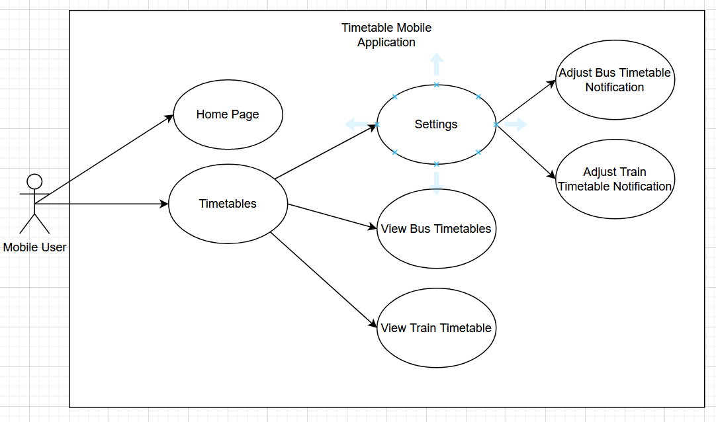

## Requirement #1: Accessing the Timetables

## Description & Priority

When the user first opens the application, they will be given two options where they can click between two tabs, one of which opens the main page of the application, and the other tab where they can have access to the different timetables that are available.

## Use Case

**Scope**

The scope of this use case is to illustrate the main functionality of my project when the actor opens the application for the first time. When they load into the application, they will be greeted with the homepage of the application where it would show them the latest news or updates regarding to the app or the changes made to the timetables. Likewise, there will be a timetable tabs where the user can view the timetables for the different trains or busses as well as having the option to change the time the application will send the reminder to the users.

**Description**

The use case diagram describes the interaction that the user will have when they are using my mobile application.

**Use Case Diagram**

**Flow Description**

**Precondition**

The application will begin to initialise when the app is downloaded on the phone.

**Activation**

The use case starts when the actor interacts or opens the timetabling application, when they do that, they will be promptly given two choices of viewing the homepage or be able to view the different timetables that the app currently supports. They are displayed in the form of interactable tabs that the actor can click.

When they clicked on the timetables section, they will be immediately given a table or list of the different times that a bus or train will arrive, giving them an idea on how they would adjust their push notifications. Likewise, the option to change when the notification can show up can also be adjusted in the timetables tab as well, making it have a dual purpose.

**Main flow**

1. The system initialises the application
2. The actor opens the mobile app
3. The system shows the home page
4. The actor chooses between either looking at the homepage or viewing the timetables

**Alternate flow**

A1: Timetables

1. The system waits for the user to select the “Timetables” tab
2. The actor selects the timetables option
3. The user chooses to view the timetables or change the push notification.

**Exceptional flow**

E1: Settings

1. The system awaits for the user’s input
2. The actor then selects the settings option in the timetables tab
3. The user can customise the time in which the app will notify them or even select the bus or train they wish to be notified for.

**Termination**

The application will simply terminate when the actor exits the app. However, the push notification feature within the app will always remain active even during an idle state.

**Post condition**

When the user opens the mobile app, the application itself will wait for the actor’s choice whether they want to view the home page. Timetables, or want to change the notification settings. If the actor decides to select the Homepage tab, they will be sent to the main page, similarly if they chose to open the timetables, the app will wait for their response.

## Data Requirements

Since my project utilises API Calls, the main source of data in that scenario would be getting the information for the timetables on websites like Bus Eireann and Irish Rails. This would then be processed in the timetabling section of my application where it would result in the user being able to customise and adjust their preferred time for when they wish to be notified of the next available train or bus.

Likewise, I also aim to utilise the Google Maps API, which in turn allow the user to find the shortest possible route to their destination, adding a similar GPS like functionality to my project. Data in this situation would have to make use of the location data so the application can track what is the most time efficient route the user can take.

## User Requirements

On a general level, the application itself should be expected to open and direct the user to the home page of the application where it will give them a short message explaining to them how to navigate and use the application. The tabs in the application will serve as a user-friendly way of switching between the main page and the timetables page where the user will adjust the push notification settings according to their preferences.

## Environmental Requirements

The application itself should be able to read API calls from sites that contain the bus, or train, timetabling schedules so that my project can utilise it and allow my application to send a reminder or a push notification letting the user know about the next available bus or train.

Another added functionality is that the application will utilise the Google Maps API to let them know of their current location and what would be the closet route that they can take to reach their destination in a timely manner.

## Usability Requirements

Due to the application being developed using “Android Studio”, one of the technical limitations of my project is that it could only be accessed by users who are using an Android Device, meaning that users using an iOS device wouldn’t have the ability to download the application normally or would work in the same way it would on a standard Android device.

However, the GUI and resolution will be curated to fit any smartphone device while also being able for Android Users to access it and customise the push notification to match their desired preferences.

## Design & Architecture

The core design and overall architecture for my project will contain the two following layers which I deem the be the most important components in the overall project. The first layer I would consider is the presentation layer, this is the front-end section of my mobile application and handles the interfaces that the user will interact with. This is crucial in the project as I aim to make the GUI accessible to all as making it comfortable for the users to look at.

## Implementation

The first feature I had to implement before adding anything else into the project, was the basic Graphical User Interface, or GUI, that is the mobile user will be interacting with. During the development process, I had to make sure the GUI was user friendly and accessible to all. After acknowledging those major components to my project, I decided utilise Android Studio’s GUI templates that allowed me to customise and change different aspect of the interface to match the standards of the mobile users.

After creating the GUI, I had implemented a Java class that allowed the me to edit and program different aspects of the application, allowing me to add text or change different components to how the overall app looks.

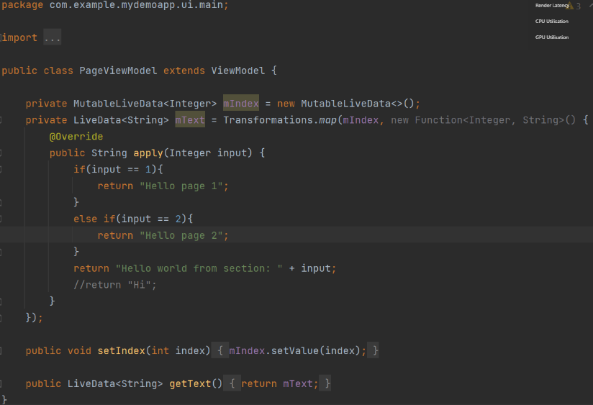

The screenshot above shows the Java class that handles the text and information to be display to the user.

## Graphical User Interface (GUI)

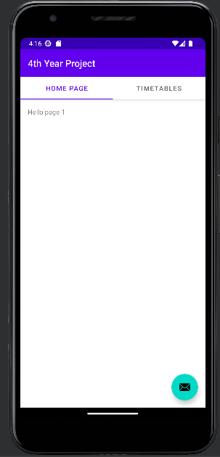

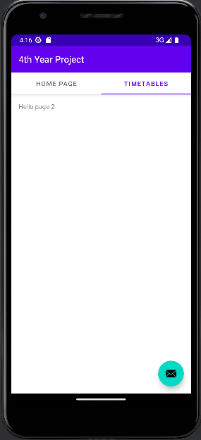

# Appendices

## Project Proposal

## Objectives

The purpose of my project was to develop a Mobile Application that, once downloaded and installed by the user, would send a notification for the next available bus of their choice. The concept behind this project was that I would have different buses such as Bus Eireann and Matthews and be able to use an API that connects the application to a server that manages their timetable for the next available bus.

The main goal of my project, and one that I aim to achieve, to build an application that sets out to make the lives of the user a little easier when it involves timetable management in terms of catching their next bus. This application could have a general audience but is more targeted to adults or young adults who must rely on public transportation to commute to work or school.

# Background

The idea of this project came from a personal experience where I accidentally missed my bus going into college on day due to a major misunderstanding between how I read the bus time schedule, to how I would get ready before then. This cost me to miss a large portion of my classes and as a result had to spend a lot of time trying to catchup to make sure I didn’t miss out on anything important.

However, this was only my own personal experiences of my poor timetable management. Another source of inspiration, and one that made choose to undertake this project, was how I could potentially make the lives of other people who went through the same problems as I have and make it a little easier and convenient so all could mutually benefit from the idea.

As previously mentioned, the objectives of this project were to develop a Mobile Application that a user could download and be notified for the next available bus. The first step before I could start my project was to do some research pertaining to Mobile Application Development and try to understand the basics of creating one. This could be done through watching YouTube videos or looking up guides on Google.

# State of the Art

Though there are some applications that exist on the internet and the app store that can help with timetable management, how I aim to set my project apart from the rest of the pre-existing apps on the market was that I would implement a feature where the user could choose whatever bus they’re taking, and the location that they’re in, and the application itself would be able to recognise that and be able to push a notification accordingly.

In layman’s terms, when the user inputs their location and their desired bus that they would wish to take, then the application would recognise that and send a notification for the next available bus that they choose based on the bus’s currently timetable. This means that the user would only have to put in the least amount of effort in telling the application what they want, while the application itself does all the hard of letting the user know when the next bus is available.

Normally other apps on the market would normally take the form of a calendar, but for my application, I aim to make it as a push notification application where they could read the notification on their screen and be able to understand when the next available bus.

# Technical Approach

The first step before I would undertake this project development is do some research on the basics of Mobile Application Development. Since I am doing this project with little to no prior knowledge to mobile application development, I will need to spend a couple of weeks trying to understand the syntax and the concept of Mobile Application Development. This could be using Google or YouTube video, but the first step before building my project would be to understand what is required and have all the basic tools installed.

Identifying the requirements will come later in the development of my project, but it could be easily identified during my research where I would be spending time on Google on what must be installed or used before creating the project. However, the basics of developing an app, such as the IDE, could be the main prerequisites in terms of the main requirements of the project. Furthermore, additional tools and dependencies would all differ depending on the amount of research I put in. In which case, those are the different requirements for the project I must integrate to assure a functional final product.

# Technical Details

During my research on what should be installed and implemented before taking on my computing project, I discovered that one of the best languages I could use before Mobile Application Development would be Java. Following on from that, I would have to install an IDE that can support Java while also downloading the most recent JDKs for the programming language to run normally without any issues.

In terms of algorithms, I would have to look up an API that would be able to pull information about the timetables for each bus that I have selected and use that API to push a notification for when the next bus is going to be available.

# Project Plan

**October**

During the month of October, when the project was first announced to us, my time was spent looking into various project ideas and testing to see whether they would work or not. This took the form of various discussion with fellow peers and by researching previously projects from other NCI Students using the NCI website. When the time came where I decided upon what project I wanted to take on, I began researching basic Mobile Application Development tutorials on YouTube.

**November**

During this month, I continued research basic ideas for what I could base my Mobile Application on, but that was when I decided to turn it into a mobile application that assists users in becoming a bit more time efficient when it came to getting to the bus stop or train station on time.

Around this month was when I was assigned to my supervisor, to which I began attending meetings where we discussed what was required of my project and how I could expand and even build upon the current existing idea to make it more innovative and creative.

**December**

By this month I should have a working prototype working while having the bare basic functionalities of my project implemented. For example, the GUI and the app’s interactivity should have been completed around this time in time for the mid-point presentation. After I have completed the first mobile application prototype, I began experimenting and implementing features like adding basic texts to different pages as well as checking if the UI is user friendly.

# Testing

There are multiple ways I can perform different tests on my mobile application app. The first and simple test would be to test the GUI’s interactivity. This could be easily done through the same IDE on Android Studio. With the use of Android Studio’s built-in emulator, I can run the app seamlessly as if it was on a physical mobile phone. Once I have done that, I can interact with the app after opening it. By clicking through the different tabs and other elements on the page to see if they’re responsive or react to basic user input.

Another form of testing that I can perform in project would be simply checking if the APIs are working and fetching the information as intended. One such way could be trying to print the timetables onto the screen of my application or by checking if the APIs themselves are online and working.

A third way of testing the app to see if it works is by having an extra or physical phone and downloading the app onto there. This method can be used to check the compatibility of certain phones, devices and even operating systems of each phone. How this would apply to me during my testing phase is that I could get different participants to help. I would run the app in Android Studio to see if it works there, then download it on to my physical phone, if both tests pass, then I can do it again on a third participant. If all three phones can successfully run the app, then the app is functioning as intended.